

----------------------------------------------------------------------------------------------------------------------------

IQAC Resolution copy

The IQAC committee along with Chair Person and Coordinator convened a meeting on 16/12/2024 and resolved to conduct Certificate course from the month January 2025 according to the feasibility of the Department of Commerce. It is also resolved to submit the details as per the check list given below well in advance by the department as per the requirements to run the proposed Certificate Course.

Checklist
- IQAC Resolution

- Department wise Resolution

- Course structure and planning

  - Date and timing schedule

  - Course outcomes, Syllabus and model question papers

  - Testing procedure

  - Feedback form

  - Model Certificate

- Students’ enrolment list

- Attendance register for 30 hours and more (Online/Offline)

- Audio visual Aids (if available),PPTs, Handouts/Printed material

- Test (Exam)and Certificate distribution

- Submission of Critical Analysis Report to IQAC

DEPARTMENT OF COMMERCE

Resolution Copy
As per the circular issued by the IQAC dated 16/12/2024 the department of Commerce has conducted a meeting on 23/12/2024 and unanimously resolved to conduct a Certificate course in the months of January and February with the duration of a minimum of 30 hours.

Notice Board
The department of Commerce is going to conduct a certificate course on E-Commerce Applications from 21/01/2025 to 20/02/2025 with min 30 working hours. Interested candidates are informed to register your names in the department on or before 20/01/2025.

Vision

A CERTIFICATE COURSE ON
E-COMMERCE APPLICATIONS

The vision of this Certificate course in E-Commerce Applications is to impart basic knowledge to the students who wish to seek their career in the area of commerce or business studies so as to empower them to satisfy the needs of the industry. Further, this certificate course is intended to give an orientation on the ever gaining importance of the e-commerce applications in the business world. Furthermore, this certificate enables the students’ community on practical approaches through result oriented and outcome-based assignments and hands-on training. In turn, the confidence levels of the learners will be boosted and the continuous assessment of their performance will absolutely yield best outcomes.

Mission
The Mission of the Certificate course in E-Commerce Application is to:
- empowering the learners by giving the basic knowledge on e-commerce applications;
- train the students on the electronic commerce environment, e-commerce market place technologies, EDI, Commerce net advocacy etc;
- assist the students with their academic needs and helping them to improve their knowledge for allied subjects also;
- provide quality programs for learners with specialized skills sets in the area of e- commerce and its applications;
- develop and conduct high quality proficiency assessment; and
- contribute to the growth and progress of the learners.
Objectives of the course
This certificate course provides an introduction to information systems for business and management. It is designed to familiarize students with organizational and managerial foundations of systems, the technical foundation for understanding information systems so as to bridge the gap between academia and industry.

Course Outcomes
After Completion of the subject student should able to
- understand the basic concepts and technologies used in the field of e-commerce and its applications;
- have the knowledge of the different types of management information systems;
- understand the fundamental principles of e-business and e-commerce;
- understand the impact of information and communication technologies on business;
- understand the tools and services used by virtual e-commerce sites;
- understand the processes of developing and implementing information systems and its linkage with e-commerce applications; and
- be aware of the ethical, social, and security issues related to e-commerce and its applications.
Course Structure
The structure of the proposed Certificate Course in E-Commerce Applications is a basic level certification course in the area of E-Commerce and Various Applications using in the domain of E-Commerce. Primarily, the certificate program in E-Commerce Applications is aimed at imparting basic knowledge and skills of several applications using in the domain of E-Commerce. It is evident that the landscape of the today’s business world is changing very drastically due to the advent of science and technology, particularly internet and internet enabled things. Hence, it is felt there is a dire need to update the required skills in the area of E-Commerce and its allied sectors. Thus, The
course is designed to address the immediate needs of the students after graduation in their attempt to go for further studies or to seek employment.

Syllabus
Unit- I
Electronic Commerce Environment and Opportunities: Background, the Electronic Commerce Environment, Electronic Marketplace Technologies. Modes of Electronic Commerce: Electronic Data Interchange, Migration to Open EDI, Electronic Commerce with www/Internet, Commerce Net Advocacy, web Commerce Going Forward.

Unit- II
Master Card/Visa Secure Electronic Transaction: Introduction, Business Requirements, Concepts, payment Processing. E-Mail and Secure Email Technologies for Electronic Commerce: Introduction, The Means of Distribution, A model for Message Handling, E-mail working, Multipurpose Internet Mail Extensions, Message Object Security Services, Comparisons of Security Methods, MIME and Related Facilities for EDI over the Internet.

Unit- III
Internet Resources for Commerce: Introduction, Technologies for web Servers, Internet Tools Relevant to Commerce, Internet Applications for Commerce, Internet Charges, Internet Access and Architecture, Searching the Internet. Advertising on

Internet: Issues and Technologies. Introduction, Advertising on the Web, Marketing creating web site, Electronic Publishing Issues, Approaches and Technologies: EP and web based EP.

STUDENTS ENROLMENT LIST
Sl. No. | Name of the Student | Group | Class/ Year | Remarks
1 | BOGI REDDY VENKATESWARLU | B.Com | II
2 | BONDIKALA MANOJ | B.Com | II
3 | DEVENDLA YEDUKONDALU | B.Com | II
4 | ETHADI PREM SAGAR | B.Com | II
5 | GADDAM ADHI NARASIMHULU | B.Com | II
6 | GADDAM JYOTHI | B.Com | II
7 | GETTIBOINA HEMANTH | B.Com | II
8 | GETTIBOINA SIVARAM | B.Com | II
9 | GETTIBOIYANA GOVARDHAN | B.Com | II
10 | GOLLAPALLI ABHILASH | B.Com | II
11 | GOLLAPALLI VIJAY KUMAR | B.Com | II
12 | KARUMANCHI MEENA | B.Com | II
13 | KATTA ANANTHA LAKSHMI | B.Com | II
14 | KESANAPALLI ELEESHA KUMAR | B.Com | II
15 | NAPERLA BABU | B.Com | II
16 | NIMMAKAYALA DINESH KUMAR | B.Com | II
17 | PINNIBOINA VANI | B.Com | II
18 | SHAIK ADIL | B.Com | II
19 | SHAIK JOSHMA | B.Com | II
20 | SHAIK KHAJA MAHAMMAD JAVEED | B.Com | II
21 | SHAIK LATHEEF | B.Com | II
22 | SHAIK MAHAMMAD SIDDIKH | B.Com | II
23 | SHAIK NANNEMMAGARI MOHAMMAD FARUQ | B.Com | II
24 | SHAIK SALMA | B.Com | II
25 | SHAIK SAMEER | B.Com | II
26 | SHAIK SHOYAB | B.Com | II
27 | SINGANABOINA PAVAN KALYAN | B.Com | II
28 | SINGANABOINA VINOD KUMAR | B.Com | II
29 | SYED ABZAL HUSSIAN | B.Com | II
30 | SYED MASOOD ALI | B.Com | II
31 | SYED MOHAMMAD AZAD | B.Com | II
32 | SYED SAMIUDDIN | B.Com | II
33 | SYED TABRAS | B.Com | II
34 | THAMMISETTY VENGALA RAO | B.Com | II
35 | THOGURU ASHOK | B.Com | II
36 | VARIKUTI RAJENDRA | B.Com | II

STUDENTS ENROLMENT LIST
Sl. No. | Name of the Student | Group | Class/ Year | Remarks
1 | ARELA JHON AGASTEEN | B.Com | I
2 | AVULA ARUN KUMAR | B.Com | I
3 | BAREGA VENKATA RAJESH | B.Com | I
4 | BEZAWADA SURENDRA | B.Com | I
5 | CHALLAKOLCHU NAGA CHANDRA | B.Com | I
6 | CHETHALA DEEPIKA | B.Com | I
7 | DUDDUGUNTA JYOTSHNA | B.Com | I
8 | DUGGINABOINA KISHORE | B.Com | I
9 | GADDAM JOSHNI | B.Com | I
10 | GETTIBOINA NAVEEN | B.Com | I
11 | GONEPUTI ARUNA | B.Com | I
12 | GUNDEBOINA SRIRAM | B.Com | I
13 | JAMMULA VASANTHA | B.Com | I
14 | JANGAM KESAVA SAI | B.Com | I
15 | MEKALA MAHESH BABU | B.Com | I
16 | MUTHAMSETTY CHARAN | B.Com | I
17 | NAGADASARI SARANYA | B.Com | I
18 | NALLABOTHULA SRIJA | B.Com | I
19 | PAGADALA CHINAMALAKONDAIAH | B.Com | I
20 | PAGADALA JASWANTH | B.Com | I
21 | PANDILLA MANOHAR | B.Com | I
22 | PIDUGU LAVANYA | B.Com | I
23 | RAVINUTHALA ANOK | B.Com | I
24 | SHAIK ABDUL KHADER | B.Com | I
25 | SHAIK DAWOOD ALI | B.Com | I
26 | SHAIK FARIYA | B.Com | I
27 | SHAIK IRFAN | B.Com | I
28 | SHAIK IRFAN | B.Com | I
29 | SHAIK MADIHA SULTANA | B.Com | I
30 | SK MOHAMMAD ABDUL KHADEER | B.Com | I
31 | SHAIK MOHAMMAD NASIK | B.Com | I
32 | SHAIK MUDAM JASEER | B.Com | I
33 | SHAIK MUDAM MOHAMMAD | B.Com | I
34 | SHAIK SAMEER | B.Com | I
35 | SHAIK SANIYA | B.Com | I
36 | SHAIK SONA | B.Com | I
37 | SHAIK ZOHEB | B.Com | I
38 | SYED AKMAL | B.Com | I
39 | SYED MOHAMMAD KAIF | B.Com | I
40 | SYED MUZASSIM | B.Com | I
41 | SYED SALMA | B.Com | I
42 | SYED THAHIR ALI | B.Com | I
43 | SYED UMRAN ALI | B.Com | I
44 | THUPAKULA NARENDRA | B.Com | I
45 | UPPUTURI RAAJITHA | B.Com | I
46 | VARIKUTI RAMAKRISHNA | B.Com | I
47 | Y YASHWANTHREDDY | B.Com | I

STUDY MATERIAL/NOTES

INTRODUCTION TO E-COMMERCE
The term Electronic commerce (or e-Commerce) refers to the use of an electronic medium to carry out commercial transactions. Most of the time, it refers to the sale of products via Internet, but the term E commerce also covers purchasing mechanisms via Internet (for B- To-B). E commerce, also known as electronic commerce or internet commerce, refers to the buying and selling of goods or services using the internet, and the transfer of money and data to execute these transactions.

SIGNIFICANCE OF E-COMMERCE
E-commerce or Electronic commerce is the buzzword of the modern day. In simple terms, it’s just buying and selling of product and services through internet. But in a broad sense, it includes the entire online process of developing, marketing, selling, delivering, servicingand paying for products and services. With the widespread usage of internet, the sphere ofE commerce has widened dramatically.

Today E commerce is an integral part of business because of various reasons like:
- Ease of use
- Accessibility all across the globe
- Great variety & easy compassion of products from different vendors
- Trusted payment channels
- Shopping can be done sitting in the convenience of home shopping, hence it is less time consuming.
It is therefore very important for any new entrepreneur to understand the significance of E-Commerce and should know how to utilize this tool for the growth and development ofbusiness.
So, whether you have an existing business or launching a brand new business, whether the volume of your business is large or small, you can always generate profit by demonstrating your products or services online, thereby acquiring a large amount of viewer exposure. Inconcise, buying and selling will result in profits and returns.
There are so many factors which makes e-commerce to come to the fore front in today’s world. Saving precious time involved in business transactions is really a prominent factor. Like for instance, net banking makes it easy to carry out money and baking

transactions in a break neck speed as compared to the real banking scenario. This asserts the fact that E commerce is beneficial to both business and consumer wise as payment and documentations can be completed with greater efficiency and reliability. Another important factor determining the flow of whole business is connectivity. Connectivity is very important for both consumers and business. E commerce provides better connectivity for all the potential candidates all over the globe, thus helping in enhancing the business without any geographical barriers. From the view point of the customer, E commerce is a good platform for hassle free shopping by sitting in your home. The customer can browse through all the products and services available and can review and compare the prices of the similar products available in the online space.
In global market scenario, the emergence of E commerce as a forerunner has opened up various windows of opportunities for a variety of online companies and investors. More and more resources are being directed into electronic securities, internet facilities, business plans and new technologies due to the boom in the space of E-commerce. As a result various new markets have emerged from E commerce itself giving a boost to the global market.

SCOPE OF E COMMERCE
Electronic Commerce is more than just buying and selling products online. It also includes the entire online process of developing, marketing, selling, delivering, servicing and paying for products and services.
India has witnessed a major breakthrough E-commerce success stories particularly in e- retail in Consumer Electronics & Fashion Apparel & Home Furnishing segments. E- commerce creates new opportunities for entrepreneurial start-ups. Ease of Internet access, Safe and secure payment modes coupled with aggressive marketing by E-
Commerce Giants has revolutionized this segment. Rapid development in mobile technology has given way to Mobile Commerce with many E-Commerce companies shifting to App only model.
Traditional Commerce and e-Commerce Definition of Traditional Commerce Traditional Commerce or Commerce is a part of business, which encompasses all those activities that facilitate exchange. Two kinds of activities are included in commerce, i.e.
trade and auxiliaries to trade. The term trade refers to the buying and selling of goods and services for cash or kind and auxiliaries to trade, implies all those activities like

banking, insurance, transportation, advertisement, insurance, packaging, and so on, that helps in the successful completion of exchange between parties. In finer terms, commerce encompasses all those activities that simplify the exchange of goods and services, from manufacturer to the final consumer. When the goods are produced, it does not reach to the customer directly rather it has to pass from various activities, which are included under commerce. Its main function is to satisfy the wants of consumers by making goods available to them, at the right time and place.

Definition of e-Commerce
E-Commerce or electronic commerce refers to the exchange of goods and services, funds or information, between businesses and consumers using the electronic network, i.e. internet or online social network. e-Commerce means trading and providing assistance to trading activities, through the use of the electronic medium, i.e. all the activities like purchasing, selling, ordering and paying are performed over the internet.

E-Commerce advantages
Can be broadly classified in three major categories
- Advantages to Organizations
- Advantages to Consumers
- Advantages to Society

Advantages to Organizations
Using e-commerce, organizations can expand their market to national and international markets with minimum capital investment. An organization can easily locate more customers, best suppliers, and suitable business partners across the globe. E-commerce helps organizations to reduce the cost to create process, distribute, retrieve and manage the paper based information by digitizing the information. E-commerce improves the brand image of the company. E-commerce helps organization to provide better customer services. E-commerce helps to simplify the business processes and makes them faster and efficient. E-commerce reduces the paper work. E-commerce increases the productivity of organizations. It supports "pull" type supply management. In "pull" type supply management, a business process starts when a request comes from a customer and it uses just-in-time manufacturing way.

Advantages to Customers
- It provides 24x7 support. Customers can enquire about a product or service and place orders anytime, anywhere from any location.

- E-commerce application provides users with more options and quicker delivery of products.
- E-commerce application provides users with more options to compare and select the cheaper and better options.
- A customer can put review comments about a product and can see what others are buying, or see the review comments of other customers before making a final purchase.
- E-commerce provides options of virtual auctions.
- It provides readily available information. A customer can see the relevant detailed information within seconds, rather than waiting for days or weeks.
- E-Commerce increases the competition among organizations and as a result, organizations provides substantial discounts to customers.

Advantages to Society
- Customers need not travel to shop a product, thus less traffic on road and low air pollution.
- E-commerce helps in reducing the cost of products, so less affluent people can also afford the products.
- E-commerce has enabled rural areas to access services and products, which are otherwise not available to them.
- E-commerce helps the government to deliver public services such as health care, education, social services at a reduced cost and in an improved manner

The disadvantages of e-commerce
Can be broadly classified into two major categories
- Technical disadvantages
- Non-Technical disadvantages

Technical Disadvantages
- There can be lack of system security, reliability or standards owing to poor implementation of e-commerce.
- The software development industry is still evolving and keeps changing rapidly.
- In many countries, network bandwidth might cause an issue.
- Special types of web servers or other software might be required by the

Vendor ,setting the e-commerce environment apart from network servers.
- Sometimes, it becomes difficult to integrate an e-commerce software or website with existing applications or databases.
- There could be software/hardware compatibility issues, as some e-commerce software may be incompatible with some operating system or any other component. Non-Technical Disadvantages
- Initial cost − The cost of creating/building an e-commerce application in-house
maybe very high. There could be delays in launching an e-Commerce application due to mistakes, and lack of experience.
- User resistance − Users may not trust the site being an unknown faceless seller.
Such mistrust makes it difficult to convince traditional users to switch from physical stores to online/virtual stores.
- Security/ Privacy − It is difficult to ensure the security or privacy on online
transactions.
- Lack of touch or feel of products during online shopping is a drawback.
- E-commerce applications are still evolving and changing rapidly.
- Internet access is still not cheaper and is inconvenient to use for many potential customers, for example, those living in remote villages.

Online shopping sites in India
Looking for Best Online shopping sites in India or Top 10 ten 2018 shopping websitein India, here in this post we going to tell you top 20 Indian online shopping sites 2018. Online shopping has been growing very fast in India, only in 2012 online shopping e- commerce site number has crossed 600 from 100. Online shopping offers fast, easy, money saving and interesting shopping experience, it has many advantages like 24 hours shopping, Shopping with coupon to get discount, shopping from Home, rich product
availability and specifications etc. Also now many sites like Shopclues, Ebay, PayTm offers some great deals every day or week which you can't resist like Jaw Dropping Deal, Sunday Flea Deal, PayTm karo, Ebay, Amazon Lightning Deals, Sankalp deals, Homeshop18.com Super deals, Flipkart offers, Amazon Happy Hours etc.
Online shopping has its drawbacks too, we cannot touch and feel the item, delay in
shipping, shipping charges make product expensive specially in low cost items, risk of loosing your money, Stolen your card details etc. Ebay and Amazon are the market leaders in online shopping in the world. However local Shopping deal site are more

popularin India. Here is a list of popular websites offering Online shopping in India.

- Amazon.in
Score (4.15)- World leader in e-commerce market recently started operation in india, Now Indians can buy Books, CDS and Electronic at cheaper price from Amzon.in. For limitedtime they offering free shipping.

- Flipkart.com
Score (4.24) - Founded in 2004 with only Rs. 400000 now in 2014 tuned over 60,000 Crore company. You can not only buy books online through Flipkart, but also mobile phones &mobile accessories, laptops, computer accessories, cameras, movies, music, televisions,
refrigerators, air-conditioners, washing-machines, Clothings, Footwears, Accessories,
MP3 players and products from a host of other categories. After takeover of letsbuy.com now flipkart is largest player of e-commerce of India.

- Snapdeal.com
Score (4.52) SnapDeal offers everything from local daily deals on restaurants, spas, travel to online products deals. They offer you best price with free shipping.

- PaytmMall.com

Score (4.85) - Started with Mobile Recharge and Bill Payment website now Paytm selling everything from Home Decor, Clothing, Laptops to Mobile at killer price. In very short time period Paytm has grown very fastly and able to place under our Top 10 Indian Shopping Website list.
- ebay.in
Score (5.00) After almost 6month of dominating at number 1 ebay has ccome down at

number two on indiafreestuff.in list. eBay.in is the Indian version of the popular online shopping portal eBay.com - world's online marketplace. Ebay has a diverse and passionate community of individuals and small businesses. Ebay offers used and fresh items with a wide network of international shipping. http://www.ebay.in
- Jabong.com
score (5.09) Jabong Fashion & Lifestyle Store offers you great discount on all listed product.They offers wide range of products from Apparel to Home needs.
- Myntra.com
Score (5.12) Myntra.com is leading online retailer of lifestyle and fashion products. Myntra offers T-shirts, Shoes, watches and more at discounted price.
- Shopclues.com
score (5.60)- Shopclues is famous for their heavily discounted Jaw Dropping deals. Shopclues is one of the best online stores that offers a wide variety of cameras, Computer accessories, Mobile, Gift, Jewellery, Cosmetics, toys, clothes, books and bag. Their Jaw Dropping deal has become most liked deal of 2012.
- Pepperfry.com
score (5.81)-Pepperfry is one of leading Indian website in selling lifestyle products ranging from men and womens clothing, home decor, jewellery, perfumes and cosmetics, furnitures, bags and accessories.

- Homeshop18.com
Score (5.99) here you find large range appliances, kitchen, cameras, mobiles, laptops, site, indian, gifts, apparel, buy, online, gifts. and more, HomeShop18 is a venture of theNetwork18 Group, India's fastest growing media and entertainment Group. Network18 operates India’s leading business news television channels - CNBC TV18 and CNBC Awaaz. HomeShop18 has also launched India’s first 24 hour Home Shopping TV channel. The company has its headquarters in Noida, UP. The website has received the 'Best shopping site" award from PC World Magazine in 2008 .

APPLICATION OF E- COMMERCE

E-Commerce
The term Electronic commerce (or e-Commerce) refers to the use of an electronic mediumto carry out commercial transactions. Most of the time, it refers to the sale of products viaInternet, but the term E commerce also covers purchasing mechanisms via Internet (for B-To-B)
E commerce, also known as electronic commerce or internet commerce, refers to the buying and selling of goods or services using the internet, and the transfer of money and data to execute these transactions

E-COMMERCE MODULES OR TYPES
E-commerce comes in six basic types
- Business-to-Business (B2B)
- Business-to-Consumer (B2C)
- Consumer-to-Consumer (C2C)
- Consumer-to-Business (C2B).
- Business-to-Administration (B2A)
- Consumer-to-Administration (C2A)

Business-to-Business (B2B)
This e-commerce type encompasses all electronic transactions of goods or services, conducted between companies, i.e. companies sell their goods online to other companies. They are not engaged in sales to the consumer public.

Business-to-Consumer (B2C)
In a Business-to-Consumer e-commerce environment, companies sell their online goods to consumers who are the end-users of their products or services. Usually, B2C E- commerce web shops have an open access for any visitor and user. There are already many virtual stores and malls on the Internet, which sell all kinds of consumer goods, such as; computers, software, books, shoes, cars, food, financial products, digital publications, etc.

Consumer-to-Consumer (C2C)
Consumer-to-Consumer (C2C) type e-commerce encompasses all electronic transactions of goods or services conducted between consumers. Generally, these transactions are conducted through a third party, which provides the online platform where the transactionsare actually carried out. eBay.com is a very good example. It is the most popular platformthat enables consumers to sell to other consumers.

Consumer-to-Business (C2B)
In C2B, there is a complete reversal of the traditional sense of exchanging goods. Here, consumers offer their products or services online and companies post their bids. Then consumers review the bids and choose companies that meet their price expectations.
A platform that is very common in this type of commerce is the markets that sell royalty- free photographs, images, and media and design elements, such as; Stock photo.

Business-to-Administration (B2A)
This part of e-commerce encompasses all transactions conducted online between companies and public administration. This is an area that involves a large amount and a variety of services, particularly in areas such as fiscal, social security, employment, legal documents, and registers, etc. These types of services have increased considerably in recent years with investments made in e- government.

Consumer-to-Administration (C2A)

The Consumer-to-Administration model encompasses all electronic transactions conducted between individuals and public administration. Examples of applications include: Education – disseminating information, distance learning, etc. Social Security – through the distribution of information, making payments etc. Taxes – filing tax returns, payments, etc. Health – appointments, information about
illnesses, and payment of health services, etc. Both models involving Public Administration (B2A and C2A) are strongly associated to the idea of efficiency and easy usability of the services provided to citizens by the government, with the support of information and communication technologies.
E-Commerce Business Model Advantages

Market Predictability
Compared to the other business strategies, the B2B E commerce business model has more market stability. B2B sectors grow gradually and can adapt to various complex market conditions. This helps to strengthen the online presence and business opportunities and get more potential clients and resellers.

Better Sales
An improved supply chain management process along with a collaborative approach increase customer loyalty in the B2B E commerce business model. This, in turn, leads to improved sales. It helps businesses to showcase product recommendations and unlock effective up selling and cross- selling opportunities.

Lower Costs
Due to an effective supply chain management process, this online business model leads to lower costs for the businesses. In most cases, the work is done through automation that eradicates chances of errors and undue expenditure.

Data Centric Process
One of the main advantages of the model is that it relies on effective and factual data to streamline the whole process. In this way, errors can be avoided and proper forecasts can be made. With an integrated data-driven approach, you can calculate detailed sales statistics.
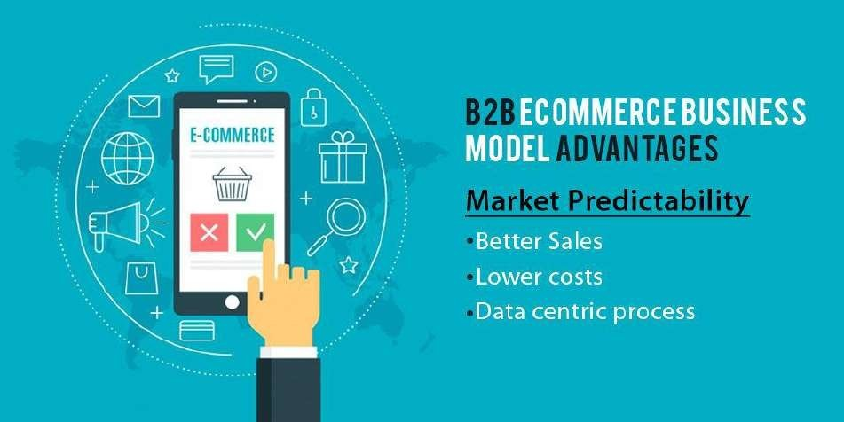

B2B E commerce Business Model Disadvantages
Just like the other business models, the B2B E commerce Business model has some flawstoo, which are:

Limited Market
Compared to the B2C model, this type of business has a limited market base as it deals with transactions between businesses. This makes it a bit of a risky venture for small and medium E commerce businesses.

Lengthy Decision
Here, the majority of the purchase decisions involve a lengthy process as there are two businesses involved. The process may involve dependence on multiple stakeholders and decision makers.

Inverted Structure
Compared to the other models, consumers have more decision making power than sellersin the B2B business model. They may demand customizations, impose specifications andtry to lower price rates.
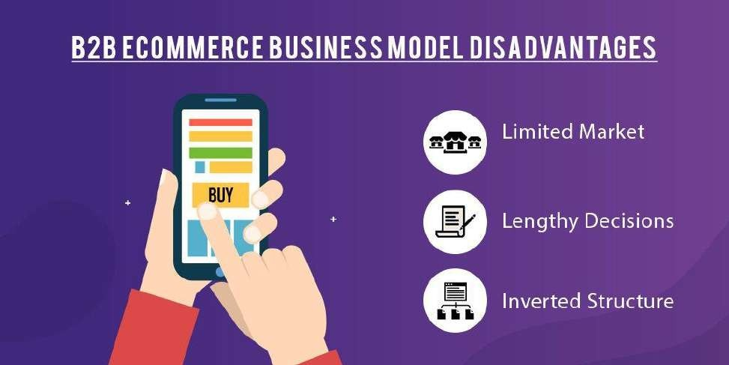

Shopping process flow Introduction
There are many different types of e-commerce websites, however the two most commonones are:
  - Business-to-Consumer (B2C) - typically designed for selling goods and services to consumers.
  - Business-to-Business (B2B) - used to build strategic relationships with other businesses, and to ease the supply and procurement processes that characterize trade among those organizations.
Sites can also have multiple roles, and a single site can provide several functions. EPiServer Commerce is a flexible platform allowing for seamless integration with external systems such as financial, CRM, inventory, warehouse and customer service systems.
Depending on how you chose to work with your online store administration and product content, you will define your user roles and groups, and give them access rights to the different parts. Example of user roles in EPiServer Commerce are content editors, marketers, business owners, and store and system administrators.

SHOPPING PROCESS
A "typical" B2C shopping workflow involves a number of interactions between a visitor on the website, EPiServer Commerce, and any integrated external system.. Depending onhow the system is set up, the shopping workflow can be fully automated so that it requires little manual attention. However, a purchase order can always be monitored, accessed andhandled manually from the Orders system if needed. In the following we will describe an example of a B2C type of shopping workflow
and theactions and tasks involved.

Cart created
In this example, a customer does not need to register on the site in order to buy. The order process actually starts as soon as the visitor selects a product and adds it to a shopping cart.A cart (basket) will be created and saved in the system, and can be viewed in Orders under"Carts". If the customer does not complete the checkout procedure, the cart will remain inthe system for a specified time.
When the customer returns to the website, the cart will be "remembered" and made available for continued shopping. Already in this early step the system will perform an inventory andpricing check, to look for availability in the warehouse, as well as discounts for selected products in the cart. This will be updated if and when the customer returns tothe cart at a later stage.

Start checkout
When the customer decides to complete the purchase and chose to "proceed to checkout",the first step of the checkout procedure is initiated.

Add address
In the second step of the checkout procedure, the shipping and billing address information is added together with the preferred type of delivery (First class/Express etc). The addressinformation can be entered manually by an "anonymous" customer, or automatically if thecustomer is logged in and has a registered user profile with address information. The system can also be set up so that it is possible to split shipments in different parts and to different addresses here.

Add payment
In step three of the checkout procedure, the payment is added to the "purchase order to be". The system will calculate the total sum including the purchase amount and the shipping fee. In this step the customer selects a payment method, for instance by credit card or PayPal. The payment will be registered and verified. This may happen instantly or after a certain specified time, depending on how the payment process is set up and the type of e- commerce solution (B2C or B2B). In this step it is also possible to split payments, if the system is configured for this.

Order created
Usually the actual purchase order is created in the system when the payment is settled. In the last checkout step, a purchase order number is created, the customer confirms the purchase, and an order confirmation is sent to the customer. The shopping cart is now converted to a purchase order which is visible with status "In Progress" under "Purchase Orders" in Orders.

Order processing
When the order is created the order processing starts. This consists of steps to check the warehouse and inventory status for the products in the order, and for creating the actual shipment. Depending on the inventory status for the products, the order may be split into more than one shipment.
- Shipment released - when the shipment is verified, it will be released. The purchase order will now appear in Orders, under "Shipping/Receiving" and "Released for Shipping".
- Add to picklist - This steps involves the addition of the shipping items to a picklist. The picklist is the list that the warehouse will use to create the physical shipping of the products in the order. This step will also produce a packing slip, which is the paper slip that will be attached to the physical package to be shipped.

Order completed/shipped
When the picklists with the different orders and their respective packing slips have been created, the order will be set to completed. In the system this involves the creation of a shipment validation number which is associated with tracking number. The tracking number can be entered manually or automatically, if such an integration exists. The tracking number connects the physical package with the shipping provider for the delivery, and is used for tracking the package on its way to the delivery address. The purchase order will now appear in Orders under "Purchase Orders" again, with status "Completed".

Return/Exchanges
Only completed orders can be subject to returns/exchanges. Depending on how the system is set up, returns can be created automatically or manually. Creating a return usually involves replacing a delivered product with another one in exchange, and/or a payment refund. When the return is created it will appear in Orders under "Shipping/Receiving" and "Returns". Order status can be for instance "Awaiting Exchange".If the return involves replacement of a new product, the shipping procedure will be initiated again. The return may also involve receiving a faulty product, in which case a receiving procedure is initiated involving the acknowledgement of a receiving receipt forthe returned product.
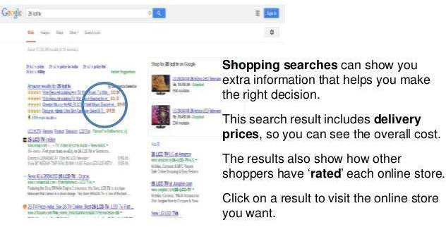

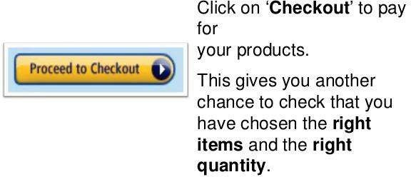

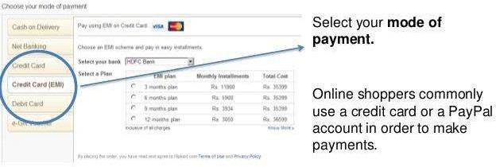

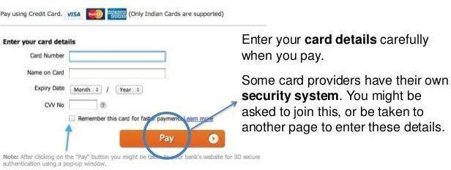

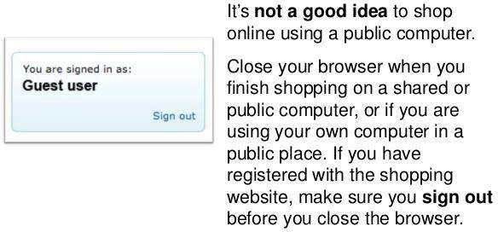

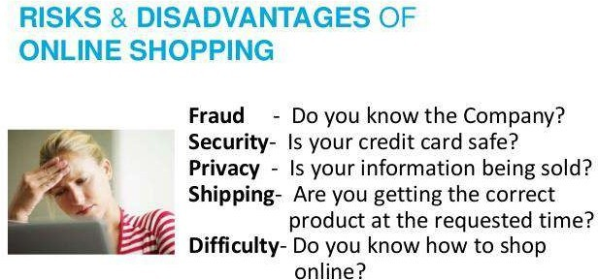

ELECTRONICRETAILING
Definition: The Electronic Retailing also called as e-tailing or internet retailing, is the process of selling the goods and services through electronic media, particularly the internet. Simply, the sale of retail goods and services online is called as electronic retailing.It follows the B2C business model wherein the business interacts directly with thecustomers without the involvement of any intermediaries

The e-retailers can be of two types:
- Pure Play e-retailers such as Amazon, that emerged as the online bookseller. It ispresent only online and do not have any physical outlet for the customers.
- Brick and click e-retailers such as Dell, that sells computers through the internet aswell as has the physical store front for the customers.

Advantages of Electronic Retailing
- Through electronic retailing, customers can save both the efforts and time.
- The wide range of products is available online, so the comparison can be made easilybefore the purchase.
- The customer can shop anytime and from anywhere, the facility is available 24*7
- The huge discounts can be availed while shopping online.
- The detailed information about the product is available online; that helps the customer to make the purchase decision.
- The electronic retailing offers the easy payment terms such as payment on delivery that instigate the customer to shop online.

Disadvantages of Electronic Retailing
- The customers may not be sure of the quality of the products offered online.
- It is the tendency of every individual to bargain before making the final purchase, but this quotient is missing in electronic retailing.
- Also, the customers may not trust on the payment gateways and fear the misuse of credit cards or any other mode of payment.
- Every customer wants to see and feel the product that he purchases, but it is not possible in case of electronic retailing where the customer makes the decision just by looking at the image.
- The product is not readily available; the customer has to wait for some time to get theproduct in his hands.
- The customer misses the emotional attachment with the seller that leads to less faith on the offerings.
The electronic retailing is the subset of E-Commerce that means, E-commerce is the principle domain that includes the e-tailing operations.

ELECTRONIC CATALOGUE
An electronic catalogue is an online publication, that is to say a graphic interface -generally an html page in which the products and services offered by a company are showed. Digital catalogues can store great quantities of items, which can be organized and classified into different categories for users to search in a more rapid and effective way.
There are different types of catalogues according to their functions. The simplest catalogues show only descriptions of the products and price lists, and do not enjoy a purchase and payment online method. Others have shopping carts, order forms and offer payment methods. The amount of functions an online catalogue has will determine the price of its development.
The main aims of e-catalogues are to advertise, to sell, to distribute, and to draw the customer’s attention. They are the digital representation of a company and a powerful e- commerce tool. In the e- commerce world we find business-consumer transactions and business to business transactions. In this way, e-catalogues are excellent communication tools between a company and its client, suppliers or other companies. For all these reasons, catalogues became a marketing tool used every day by different types of organizations.
There are different types of electronic catalogues according to the way they appear on the Internet. Retailer’s e-catalogues are generally independent pages on the Internet, and their aim is to promote and sell products and services. But, big companies generally include their e-catalogues on their general websites. Generally, they are not used as tools for selling but as means to promote products and services
and to draw the customer’s attention. There are also malls, that is to say e-catalogue groups –ebay.com for example. In this case, an Internet provider gathers different companies’ digital publications, showing a great number of offers made by the users.

Advantages E-catalogues
E-catalogues bring many advantages to different companies. Here we show them to you for you to consider catalogues as a promotion tool for your company:

Low costs
Unlike conventional catalogues, these e-catalogues allow you to save money, since you will not need to spend on paper and printing. For this reason, they are perfect for small and medium-sized companies, which will have, with them, the possibility of getting into the world market.

Market expansion
Thanks to the possibilities that the Internet provides, people around the world will be able to gain access to your online catalogues any time. With these catalogues, different companies gain new customers, providing a faster and more comfortable service to consumers. By using these catalogues, users will be able to search for products and services, place orders, make payments by credit cards or payment portals, and clear up their doubts. In this way, sales increase considerably.

Interaction
Unlike printed catalogues, digital catalogues allow a direct relationship between the company and its clients. With an e-catalogue, a company can inform about its products and services to its clients, who will contact the company’s representatives to clear up their doubts, to make comments or suggestions. Because of this, company will be permanently updated about the fluctuating necessities of their target.

Information for customers
With these catalogues, each company will be able to provide information on the products and services it offers and links to other websites for customer to get complementary information on the subjects the company’s website leads with.

Regular update
E-catalogues content is stored on a server to which navigators from all over the world have access. They can be updated from the server in a regular, fast and easy way. What is more, the changes made are immediately available for customers to see. In this way, catalogues show the latest about new products, prices, points of sale, new technology incorporations, etc.

WHAT IS INTERACTIVE ADVERTISING
Interactive advertising is a shift from the more traditional (and perhaps, boring) method of advertising, which relies on customers seeing and remembering a typical magazine ad or hearing about a product on the radio. Interactive advertising is about developing two-way communication between brand and
customer, because the brand has developed advertising that requires the
customers to react in some type of unusual way (not simply going to a store and buying the advertised item).You're probably most accustomed to seeing the interactive nature of advertising through the medium of the internet, right? After all, you have to click on links to view content and choose to follow through on an advertisement you see on your favorite news site. Savvy marketers have determined that interactive advertising can take many different forms (likeJetBlue discovered), in an effort to open up the dialogue between a business and its audience, engage them, build relationships and ultimately, convert them into customers.

BENEFITS AND DISADVANTAGES
Interactive advertising, like any form, has both advantages and drawbacks that marketers should consider. Among them:

Benefits
- Gives viewers more control over their interpretation of your content
- Proves the importance of the consumer (by asking them to respond or react in someway)
- Opens lines of interaction and dialogue between a brand and its audience

Disadvantages
- Can be more costly in terms of finances and time
- Requires a clear understanding of the audience being targeted

IMPACT OF E COMMERCE
E-commerce is about much more than marketing or selling. It impacts significantly on all the functional areas of a business. The largest and most-successful e- commerce businesses have invested hugely over many years to develop their IT systems, business processes and capabilities.

THE ADVANTAGES & DISADVANTAGES OF ADVERTISING ON THEINTERNET
More than 4 billion people use the internet. If you want to build your business brand, reach prospective customers, and make more sales, you can no longer ignore digital advertising. But beware: there are ineffective strategies that can eat your ad dollars in record time, leaving you with little to show for your advertising efforts. For many businesses, however, the advantages outweigh the disadvantages. Advantage: Your Customers Are on the Internet
Do you know anyone who doesn’t use the internet? The fact that it is so ubiquitous is probably the most compelling reason to get on board. Platforms like Facebook, Instagram, Twitter and LinkedIn give you ample opportunities to put your products or services in front of potential customers. The Google Display Network is a true advertising behemoth with more than 2 million publisher sites on which you can advertise.

Advantage:
Closely Monitor Spending
You can spend thousands of dollars on a 30-second television ad that might reach someonewho might be interested in what you have to sell someday. You can also spend thousandsof dollars on internet ads, and only pay when people who are interested in your products click on your ad. With digital ads, you can set a spending cap and limit the number of timesa prospective customer sees an ad in a given period.

You Can Track Your Results
Digital advertising allows you to monitor and track the results of all your campaigns. Youcan find out when a lead converted into a sale, note the platform where it happened, and determine what kinds of ads are working best for your particular demographic. The internetwith all its minute tracking abilities allows you to measure the return on investment of your marketing dollars.

Disadvantage It’s Complicated
There are lots of choices when it comes to advertising on the internet. You can choose search
advertising, so your ads show up when a target audience is looking for just what you offer or display ads that appear where your most likely prospects roam on the internet. There are even native ads that show up on publisher sites and blend in so well that they appear not to be ads at all. Then there are remarketing ads that target someone who’s visited your website with a customized message that appears in front of them some whereelse on the internet. Add to those choices the way you pay. With pay-per-click ads, you pay when someone clicks, but how much are you willing to pay? For those search ads, you’ll need to identify key search terms and decide how much to bid on each word. There are lots of levers to pull.

Mistakes Can Be Costly
Because digital advertising is complicated, it’s not uncommon for businesses to make mistakes. Choose the wrong keywords, neglect a bidding cap, target ineffectively, or leave a campaign running when you thought it was off, and you can spend a fortune without turning a single lead into a sale. For example, if you run a campaign on Facebook but your customers are more likely to be LinkedIn users, you’re unlikely to convert a lead. If you don’t cap your bids, you could blow through the money you thought would last months ina matter of days.

Competition Is Fierce
It depends on your products and market, but internet advertising competition can make adsprohibitively expensive. Those keyword bids? If you can only afford 10 cents a word, but your competitor can pay
$10, you don’t stand much of a chance. For some businesses, it makes sense to build a good website and then rely on traditional advertising methods that have always worked in the past.

Ad Fatigue Is Common
Have you ever been on a site and seen an ad for a product on which you recently ran a search? That’s internet advertising at its most typical, but have you also noticed that after a while, those ads don’t even register on your radar? It’s like they’re invisible. It’s a common and pervasive problem with running ads on the internet. If the campaigns aren’trun correctly, your brand and its products suffer from ad fatigue.

The Impact of Electronic Commerce on Business
E-Commerce and E-Business are not solely the Internet, websites or dot com companies. It is about a new business concept that incorporates all previous business management and economic concepts. As such, E-Business and E-Commerce impact on many areas of business and disciplines of business management studies.
- Management Information Systems – Analysis, design and implementation of e-business systems within an organization; issues of integration of front-end and back-end systems
- Human Resource Management – Issues of on-line recruiting, home working and ‘Entrepreneurs’ works on a project by project basis replacing permanent employees.
- Finance and Accounting –On-line banking; issues of transaction costs; accounting and
auditing implications where ‘intangible’ assets and human capital must be tangibly valued in an increasingly knowledge based economy.
- Economics –The impact of e-commerce on local and global economies; understanding the concepts of a digital and knowledge-based economy and how this fits into economic theory
- Production and Operations Management –The impact of on-line processing has led to reduced cycle times. It takes seconds to deliver digitized products and services electronically; similarly the time for processing orders can be reduced by more than 90 per cent from days to minutes. Production systems are integrated with finance marketing and other functional systems as well as with business partners and customers.
- Marketing – Issues of on-line advertising, marketing strategies and consumer behaviorand cultures. One of the areas in which it impacts particularly is direct marketing. In the past this was mainly door-to door, home parties and mail order using catalogues or leaflets.
- Computer Sciences – Development of different network and computing technologies and languages to support e-commerce and e-business, for example linking front and back office legacy systems with the ‘web based’ technology. 8. Business Law and Ethics – The different legal and ethical issues that have arisen as a result of a global ‘virtual’ market issues such as copy right laws, privacy of customer information, legality of electronic contracts etc

FEEDBACK FORM

- Were the objectives of the course clear to you?
  - Yes
  - No
- Did the course contents meet your expectations?

  - Yes
  - No
- The level of the course was
  - Good
  - Not Good
- The contents were illustrated with
  - More examples
  - Few examples
- The course exposed you to new knowledge and practices
  - Agree
  - Not agree
- Will you recommend this course to your next batch
  - Yes
  - No

TEST

Which dimension of e-commerce enables commerce beyond the boundaries of the country?
  - Richness
  - Interactivity
  - Global Reach
  - Ubiquity

is not a major type of electronic commerce.
  - Consumer to Business
  - Business to Consumer
  - Business to Business
  - Consumer to Consumer

Which is not one of the three phases of electronic commerce?
  - Reinvention
  - Preservation
  - Consolidation
  - Innovation

Which of the following describes the definition of electronic commerce?
  - Doing business
  - Sale and purchase of goods
  - Doing business electronically
  - All of the above mentioned

Which e-commerce model involves the sale of goods or services from businesses to the general public?
  - Business to Government
  - Business to Consumer
  - Business to Business
  - Consumer to Business

Which e-commerce transaction provides the benefits of eliminating the requirement of a middleman?
  - Business to Business
  - Business to Government
  - Consumer to Business
  - Business to Consumer

The idealistic market envisioned at the outset of electronic commerce’s development is referred to as .
  - Bertrand market
  - Baxter market
  - Bailey market
  - Bergman market

is an e-commerce model which focuses on consumers dealing with one another.
  - Business to Business
  - Consumer to Consumer
  - Consumer to Business
  - Business to Consumer

Which of the following was the primary source of financing during the early years of electronic commerce?
  - Venture capital funds
  - Bank loans
  - Initial public offerings
  - large retail firms

Which of the following is/are considered examples of the Consumer to consumer (C2C) model?
  - Amazon.com
  - e-bay
  - Rentalic.com
  - All of the above

Which of the following technology is not used to collect the information about you?
  - Anonymizers
  - Spyware
  - Gmail
  - Cookies

Which of the following is the set of planned activities that are designed to result in a profit in the marketplace?
  - Profit model
  - Business model
  - Business plan
  - Revenue model

Which of the following is not a key element of the business model?
  - Competitive advantage
  - Market strategy
  - Universal standards
  - Value Proposition

In which year WWW (World Wide Web) was introduced?
  - 1996
  - 1994
  - 1990
  - 1991

Which of the following is an early form of e-commerce?
  - EDI
  - SCM
  - Both of these
  - None of the above

The reason why digital products are best suited for Business Consumer e- commerce is that they:
  - Can be mass-customized and personalized

  - Are commodities like products
  - Can be delivered at the time of purchase
  - All of the above

is an example of an Internet portal.
  - Yahoo
  - e-bay
  - Amazon
  - Face book

Which of the following is categorized as a major Business-to-Consumer business model?
  - Service provider
  - Transaction broker
  - Industry consortium
  - Content provider

Which of the following business model consists of an independently owned vertical digital marketplace for direct inputs?
  - Private industrial network
  - E-distributor
  - E-procurement
  - E-exchange

is referred to as the percentage of customers, by whom a Web site is visited and something is purchased by them.
  - Conversion rate
  - Spam
  - Affiliate programs
  - Click-through

ATTENDENCE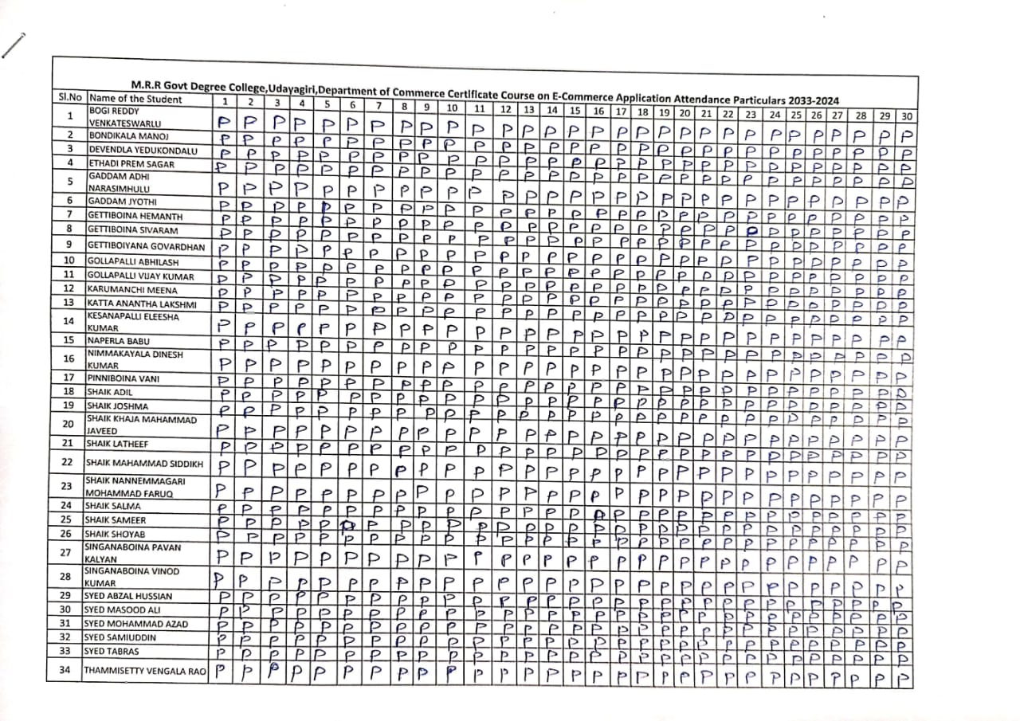







THE DEPARTMENT OF COMMERCE

Critical Analysis Report
The Department of Commerce has conducted a certificate course (Institutional Permission) on E-Commerce Applications from 21/01/2025 to 20/02/2025 with the minimum duration of 30 hours. According to the IQAC and Principal’s instruction, the course has been conducted as per the the feasibility and convenience of the Department of Commerce and availability of the students during this academic year. 40 students were registered and completed the course as per the schedule. The objectives of the course that were specified in the beginning of the course were fulfilled to the core.

Outcomes of the Course
- Students could come to know the basics of E-Commerce and its applications.
- Students could use the e-commerce application on their own.
- Students could work on the present business environment.
- Students could fill the gap between the academia and industry with their expertise knowledge in the area of e-commerce. .

Hence, the certificate course on E-Commerce Applications is very useful to all the Students. The feedback from the students was collected and analyzed. All the students from across the streams showed interest to do this Certificate course and requested to
continue the same course further for the successive batches.

Thank you



